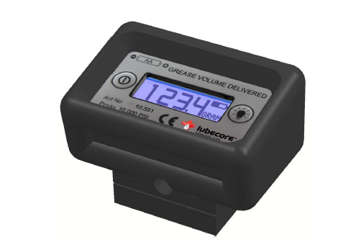**Lubecore Volumetric Grease Flow Meter**

The Lubecore volumetric grease flow meter accurately measures and displays the volume of grease that is delivered, in both metric (cm³ or g) and US units (US fl. oz. or oz.). The meter is rated for extremely high pressure with a maximum pressure of (10 000 psi) or 700 bar making it applicable for use with the Lubecore pump and many other grease guns as well.

The Lubecore volumetric grease flow meter works faultlessly with the Lubecore pump and with most kinds of grease guns. Prior to dispensing grease, you can reset the meter with the press of a button.

The meter displays the amount with large (9 mm) easy to read numbers on the display with the desired unit (cm³, g, oz., or fl. oz.).

The flowmeter has a re-settable counter (for the total amount).

With the help of the Lubecore volumetric grease flow meter, it is now possible to confirm the correct volume of grease has been delivered based on the bearing manufacturer's specifications.

|  |  |
| --- | --- |
| **Technical data** | **Volumetric Grease Flow Meter** |
| Material, housing: | Aluminium, anodized |
| Seals: | NBR |
| Working pressure: | Max 70 MPa/10,000 psi |
| Flow: | Max 1,000 cm³/min |
| Measuring accuracy: | ±3% up till 30 MPa (4 400 psi) |
| Height of digits: | 9 mm |
| Number of digits: | 4 |
| Battery: | 1 piece of AA (1,5 V) |
| Medium: | Grease up to NLGI 2 |
| Weight: | 0.3 kg |
| Connections: | ISO-R1/8 female |
| **Part Number:** | **10.551** |

**Volumetric Grease Flow Meter Layouts**

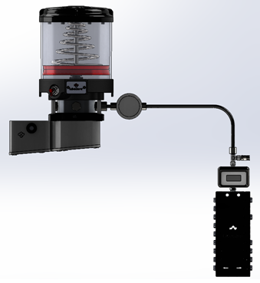

**Figure 1**

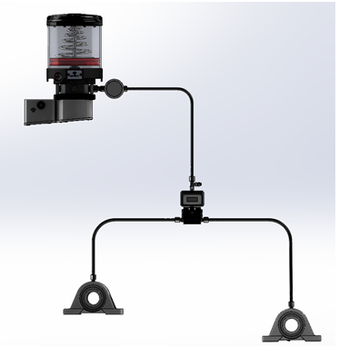

**Figure 2**