**Servicing Groeneveld Twin Systems**

Making a JIC#4 Connection on a GV Twin Pump allowing for the use of Lubecore Korilla hose to repair G.V Mainlines.

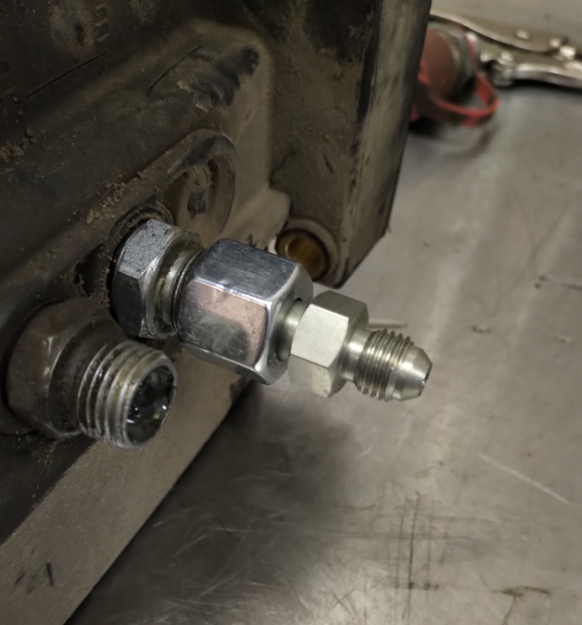**Lubecore services all makes and models of automated greasing systems.**

**Adapting a GV twin outlet to #4 JIC**

Adapting a GV twin outlet to #4 JIC makes it simple to use our high pressure large Korilla lining. To replace or repair existing GV mainline.

**Figure 1**

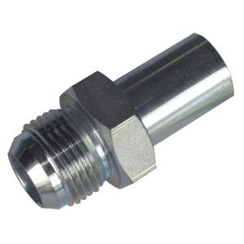

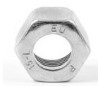

|  |  |  |
| --- | --- | --- |
| **Required Parts to Convert GV outlet to #4 JIC – Kit # 54.565** | | |
| **Name** | **Lubecore Part #** | **Quantity** |
| Ferrule 10mm | **21.273** | **2** |
| Tube Nut 10mm | **21.274** | **2** |
| Male JIC #4 X Metric 10mm stand pipe | **21.275** | **2** |

**Connecting Lubecore ¼ ID Large Korilla**

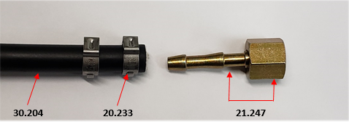

**Figure 1**

|  |  |  |
| --- | --- | --- |
| **Required Parts to Connect Lubecore Mainline** | | |
| **Name** | **Lubecore Part #** | **Quantity** |
| Lubecore Korilla ¼ ID- Filled | **30.254** | **20ft** |
| S.S clamp Lubecore Korilla ¼ ID | **20.233** | **4** |
| #4 JIC connector for Large Korilla | **21.247** | **4** |

**Correct Placement of S.S Clamps**

Correctly positioning the S.S clamps as displayed in **Figure 2 below** will ensure the mainline is securely locked in place, preventing the mainline from blowing off.

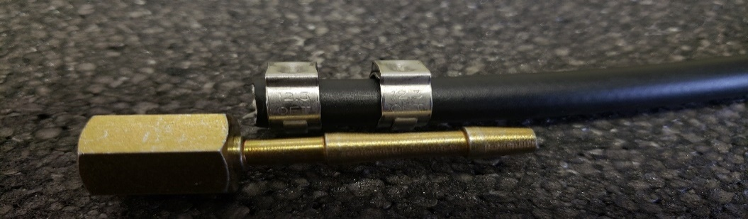

**Figure 2**

